Using GenomeStudio
Open the GenomeStudio software either through Windows Programs or through the shortcut on the Desktop.
Enter the Registration Information (this will only need to be done the first time you open the software). After filling in the information and clicking “Register”, the software will open.
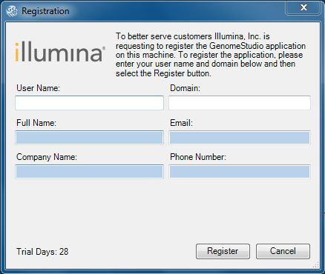

After the software opens click the open folder icon in the upper left and navigate to your GenomeStudio .bsc file to open the file.

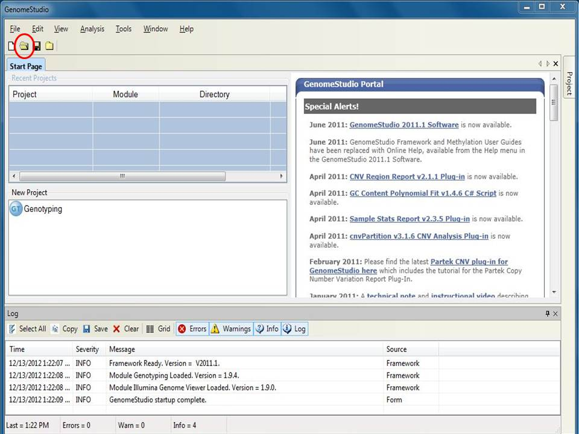

After the .bsc file is open, click on “View” then click “Load Custom View”.

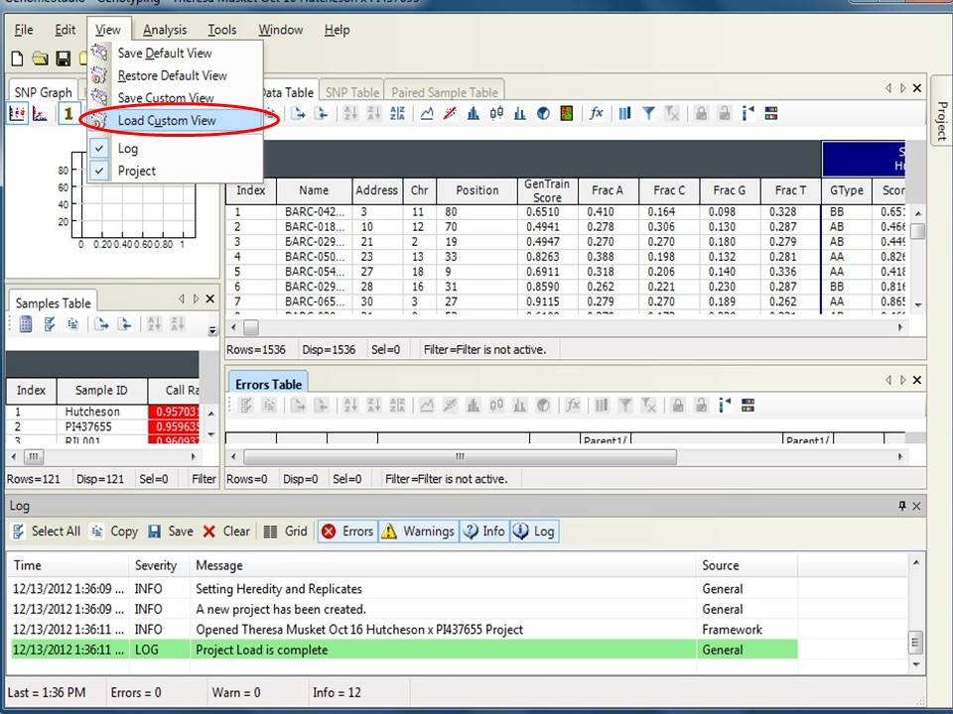

Browse to select the folder labeled “Genomestudio Desktop” and click “OK”. The software will load the necessary files from the folder.

To save the current view, click on “View” again and choose “Save Default View”.

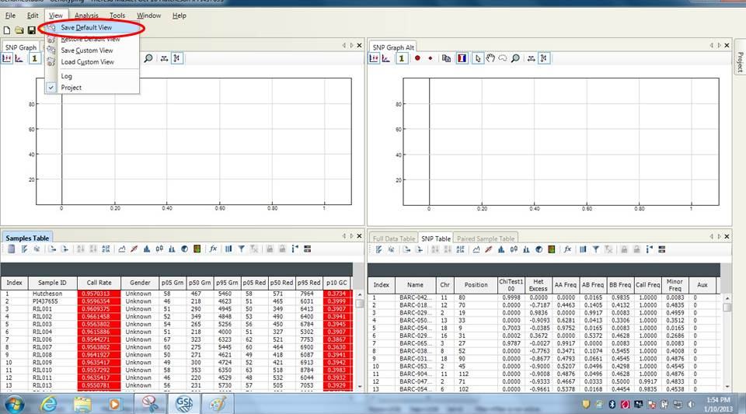
This will now be the “Default View” for data analysis after opening a .bsc file.
After the custom view is open, on the upper right “SNP Graph Alt", click one time each on the two boxes circled in red below:
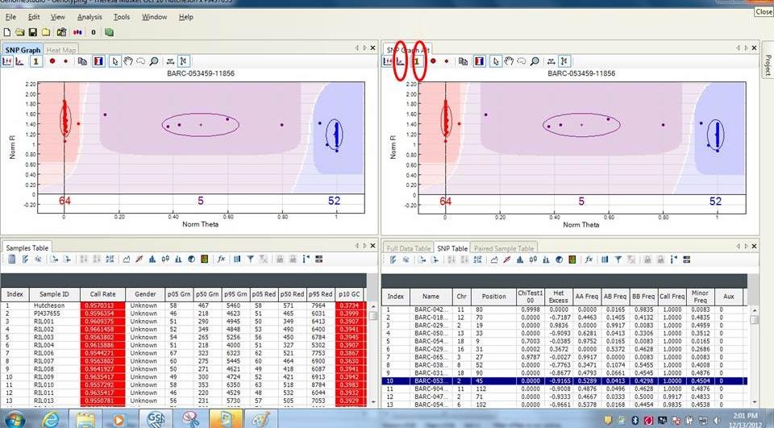
After which the desktop will appear as below showing normalized data upper left, samples intensities upper right, samples information lower left and SNP information lower right:
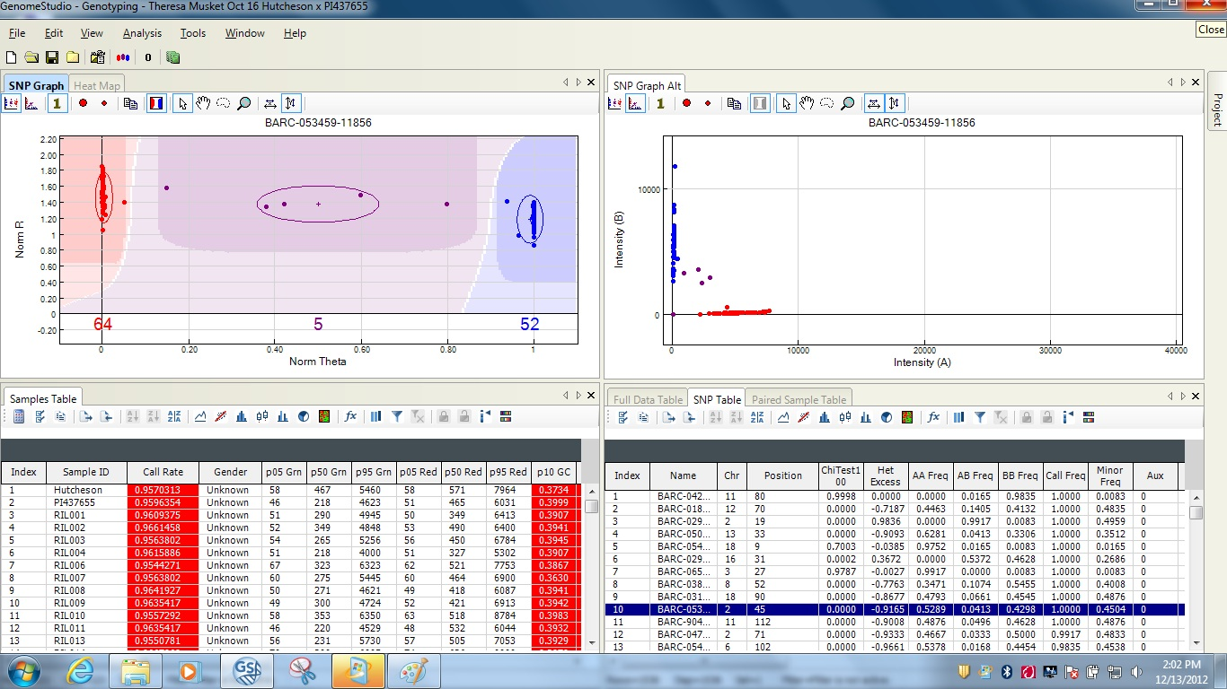
Data is now ready for review.
Further software information can be found within the GenomeStudio Documents folder.
This is where the fun begins!
Starting with the first loci in the “SNP Table” look at the “SNP Graph” to confirm the software has called the data correctly. If the software is incorrect, you can move any of the circles by holding down the shift key and left click the mouse to drag the circle where you think it should be. Circles can also be re-sized by again holding down the shift key and left clicking the mouse on the line of the circle and dragging it to a smaller or larger size. Move on to the next loci in the “SNP Table” and again make sure the data is called correctly adjusting if necessary. This must be done for all 5398 SNPs.
After the data has been reviewed, you can generate the Finial Report, this contains the data in spreadsheet form for further use.
To report the SNP call for each loci do the following:
Go to “Analysis” – “Reports” – “Report Wizard”
click “Final Report” – click “Next”
choose “remove them from the report” or “zero them in the report” I choose “Zero them in the report” – click “Next”
choose “Include zeroed SNPs in the report” or “Remove zeroed SNPs from the report” I choose “include zeroed SNPs in the report” it is default
for intensity only SNPs choose “Exclude Intensity only SNPs” – click “Next”
click “Matrix” – select “Forward Strand” from drop down menu, then uncheck “Include GenCall Score” – click “Next”
confirm that the location and name of the file to be created is to your liking - click “Finish”

To get the AB calls, instead of the SNP calls, under “How would you like to format you final report?” choose “Matrix” and the “AB” from the drop-down menu. All other settings can be as you prefer.

